
Checklist for specific learning difficulty (SpLD)
This checklist is designed to help identify whether you have a specific learning difficulty such as dyslexia. It is not a full diagnostic assessment but will indicate whether you might benefit from a full diagnostic assessment.
You do not have to return the completed checklist to the Open University.
If you want to discuss the results with an adviser you should contact us after you have completed the checklist.
You may find it helpful to think about your current concerns and past experience. This checklist can help you do that. It will also help prepare you for the discussion you are likely to have with an assessor.hink carefully, but not for too long, about your answers. You might find it useful to discuss some questions with people who know you.
You can use this checklist by marking with a cross (X) the appropriate boxes and adding any comments that come to mind as you reflect on each section.

Current concerns

Table 1
When you are writing do you ... | Yes | No | Some-times
Find organising ideas on paper more difficult than explaining them verbally?
Find it hard to listen and take notes at the same time?
Find it hard to copy accurately from a board?
Struggle to remember the word you want to describe or name something?
Miss out letters or parts (syllables) of words?
Confuse or reverse letters in a word (e.g. b/d, f/t, n/v)?
Anything else you would note about your writing? (add details below)

Table 2
When you are reading, do you ... | Yes | No | Some-times
Misread or misinterpret a passage?
Find reading an arduous and slow process?
Only make sense of a passage by re-reading it several times?
Take a long time to scan a passage for the main point?
Find some fonts and backgrounds easier to read than others?
Anything else about your reading? (add details below)

Table 3
  When you are speaking, do you often … | Yes | No | Some-times
Find it difficult to respond verbally at speed?
Find it difficult to recall the words that you need?
Anything else about verbal communication (add details below)

Educational history
Table 4
  Thinking back over your years at school, do you remember … | Yes | No | Some-times
Being later in learning to read or write than others?
Finding it hard to memorise spellings?
Not wanting to read aloud in class?
Misreading numbers or writing them incorrectly?
Having difficulty learning multiplication tables?
Thinking about secondary school do you remember … | Yes | No | Some-times
Having any extra support for examinations?
Any particular feedback from your teachers?
Any other comments? (add details below)

Everyday life
Table 5
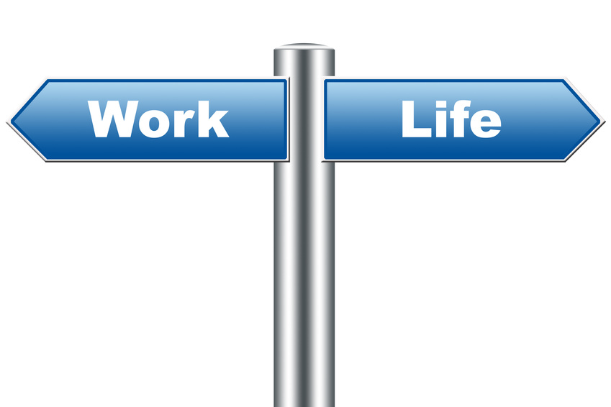  In your everyday life now, do you find yourself generally … | Yes | No | Some-times
Avoiding reading?
Avoiding writing?
Having difficulty when filling in forms?
Tending to get telephone numbers mixed up?
Confusing dates and missing appointments?
Not being able to find the right word for something?
Needing written reminders for everything and still forgetting?
Having difficulty organising your paper-work?
Confusing left and right?
Dreading verbal instructions?
Are your difficulties shared by other family members?

I ticked mainly ‘Yes’ or ‘Sometimes’
If you ticked “Yes” or “Sometimes” to most of the questions in one or more of the sections, you may have a specific learning difficulty which means you may benefit from applying for support through Disabled Students’ Allowance.
Disabled Students’ Allowance (DSA)
If you are eligible for a DSA, it could help you to pay for some of the extra study related equipment and services you have to purchase as a result of your disability. This might include specialist technology, non-medical help (such as disability-related study support at home).
To apply for Disabled Students’ Allowance (DSA) or to apply for additional arrangements for examinations you will need a full diagnostic assessment. which confirms that you have a specific learning difficulty.

There is information on Student Home about:
- Disabled Students’ Allowance. Please note that an application can take up to 14 weeks.
- Diagnostic asessment for specific learning difficulties including a video about a student’s experience on the Specific learning difficulties - diagnostic assessments page.
- Finding an assessor., a qualified person who can carry out a full diagnostic assessment with you.

Some of the terms used above can be confusing so here is a list of definitions to help:
Diagnostic assessment: a set of activities delivered by a qualified professional (independent of the University) to assess whether someone has a specific learning difficulty. It results in a report identifying strengths and weaknesses and suggests strategies that will help individuals to deal with their specific learning difficulty.
This is acceptable evidence of a disability when applying for Disabled Students’ Allowance (DSA) and as acceptable evidence by the University if you need to apply for additional examination arrangements.
Disabled Students’ Allowances (DSA): a non means tested grant from the government to help with the additional costs of studying if you have a disability. The application process can take up to 14 weeks.

The booklet Studying with Dyslexia has lots of useful hints and tips for studying with the OU if you have a specific learning difficulty.

Once you have looked at all the information if you have more questions you can contact your Student Support Team. You’ll find their contact details in the StudentHome Help Centre.

I ticked ‘no’ more often than ‘yes’
If you have ticked ‘no’ more often than ‘yes’ then you may find that developing your study skills can help.
Many people experience some study difficulties, especially under pressures of time. This may be for a whole variety of reasons such as gaps in education or poor school experience.
You can discuss any difficulties with your module tutor or you may contact a member of your student support team. You’ll find their contact details in the StudentHome Help Centre.

